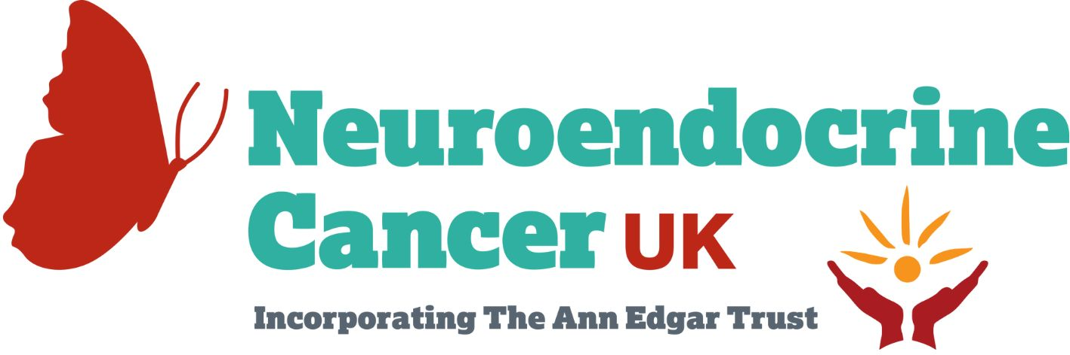

Dear [insert MP or Councillor’s name]

Neuroendocrine cancers, also known as neuroendocrine neoplasms (NENs), are a diverse group of cancers - the incidence of which has increased 371% since 1995.

NENs are now the 10th most prevalent cancer in England.

However, persistent challenges and inequities in NEN diagnosis and disease management need urgent attention.

Our campaign, “Neuroendocrine Cancer: Ideal Patient Care Pathway,” is designed to address these challenges and provide evidence-based recommendations to decision-makers for improvement. Developed in collaboration with a multidisciplinary advisory group and aligned with the NHS Long-Term Plan’s objectives, this pathway aims to integrate seamlessly into NHS England.

We seek not only to support those with NENs but also to contribute to the broader goals of the NHS and Major Conditions Strategy: addressing inequities, streamlining care, and ensuring everyone receives the healthcare and expertise they need.

We prioritise the effective integration of this pathway within existing expert multidisciplinary teams across England, ensuring optimal care for all individuals with NENs. By establishing clear guidelines for diagnosis, care, and support, we empower individuals living with NENs to access the right care at the right time and place - and support a more efficient utilisation of NHS resources.

Join us in supporting the Neuroendocrine Cancer Patient Care Pathway campaign.

Your endorsement can raise awareness and help us drive change to provide equitable care for individuals affected by Neuroendocrine Cancer.

Stand with us to create a compassionate and effective healthcare system for Neuroendocrine Cancer patients in the UK.

For more information about our campaign and how you can make a difference, please contact us: catherine@nc-uk.org

Thank you for considering our request: Together, we can bring about positive change and ensure a brighter future for those living with Neuroendocrine Cancer.

