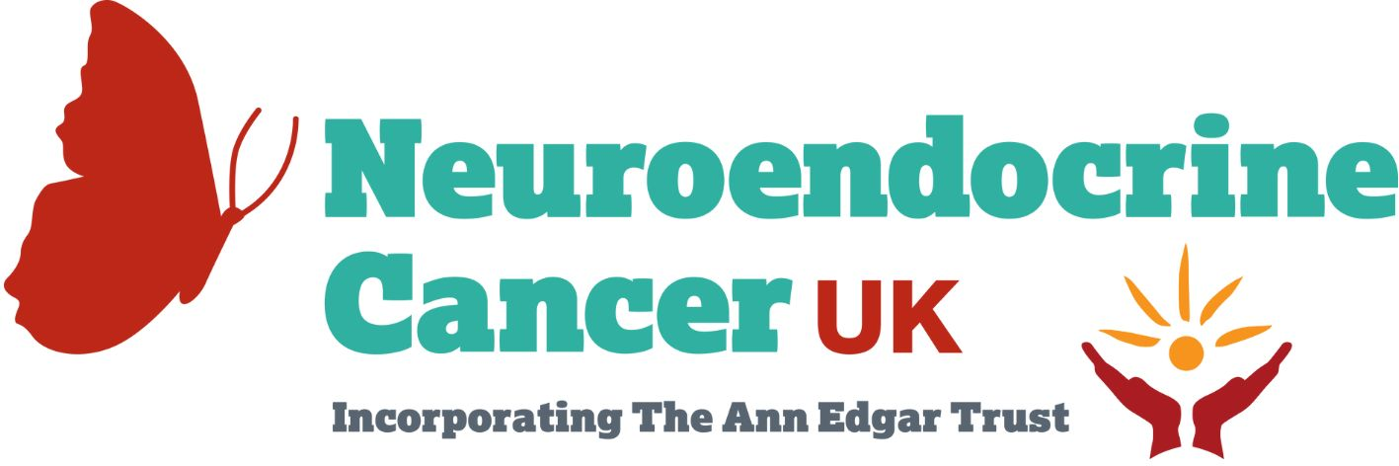
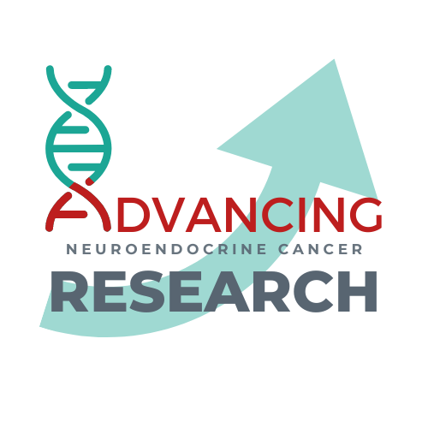

Practice-changing grants
A collaboration between Neuroendocrine Cancer UK & UKINETS
APPLICATION FORM
- Please complete this form to apply for a practice-changing grant.
- The deadline for receipt of applications is Sunday 1st October 2023
- Send the completed form to campaigns@nc-uk.org
- The successful applicants will be announced December 4th, 2023.
Application Criteria for Practice-changing grants:
These grants are open to any healthcare professional
All projects must meet the following criteria and will be judged against this:

- A clear potential benefit for people with neuroendocrine cancer must be demonstrated.
- Outcomes to be demonstrated within 12 months.
- A robust outcome measurement.
- Potential to scale regionally, nationally or across NC entities for pilot projects and replication in other centres.
Amount
Up to £10,000 will be awarded to successful applicants.

Name and position of Practice Changing Grant Lead
Name of Hospital / University
MDT team involved in practice changing grant (please provide names and positions)
Title of Practice Changing Grant
Background and context behind the grant
Aims and objectives of research
How will this project provide a benefit for people with neuroendocrine cancer? (Will it also impact the lives of people with other conditions, if so, which?)
Methodology and how will the outcomes be measured?
Timescales of Grant
Funds required with budget breakdown
Do you have other sources of funding for the project? If yes, please list them
Anticipated outcome of research
If this project demonstrates positive outcomes, is there potential to roll it out regionally or nationally? If so, how will this be achieved?
Any additional relevant information

