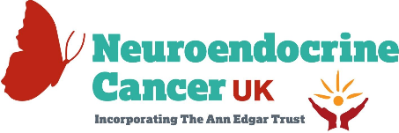

NCUK & UKINETS Pump-priming grant
We are pleased to announce the 2023 round of the NCUK & UKINETS pump-priming grant in support of neuroendocrine cancer (NC) research.
Aim
The aim of this grant is to provide pump-priming funds to support research projects designed to improve outcomes for patients with neuroendocrine cancer.
Application criteria for pump-priming grant
All projects must fulfil the following criteria and will be judged against this:
- Proposals from researchers in all relevant fields of NC research in the UK & Ireland.
- Research projects must improve outcomes for patients with neuroendocrine cancer.
- Potential to lead to more substantive funding.
- A robust outcome measurement.
- Ambitious proposals that encourage collaboration between centres are encouraged.
- The funds are to be used to cover research costs but not travel expenses, salaries or major equipment. This grant is not to be utilised as part of a bigger research programme.
Amount
One grant of up to £30,000 will be awarded.
Application Process
- The application should be completed on the template below.
- The deadline for receipt of applications is Sunday 25th February 2024
- Please send completed form to campaigns@nc-uk.org
- Applications will be reviewed by the research committee of UKINETS and the NCUK team.
- Successful applicants will be announced in April 2024.
Our ask of you
Successful applicants will be asked to:
- Create an introductory video with a project overview including timelines and expected outcomes to be shared with the NCUK community.
- Create a report at the end of the project.
- Credit NCUK & UKINETS in all presentations of their work, including the use of the two logos.
- Provide an account to which funds should be transferred within 2 weeks of receipt of award.
If you have any questions, please contact campaigns@nc-uk.org
Name and position of pump-priming grant Lead

Name of Hospital / University

MDT team involved in pump-priming grant (please provide names and positions)

Title of pump-priming grant

Brief lay summary (5 lines max)

Background and context behind the grant

Aims and objectives of research

How will this project provide a benefit for people with neuroendocrine cancer? (Will it also impact the lives of people with other conditions, if so, which?)

Methodology and how will the outcomes be measured?

Timescales of grant

Funds required with budget breakdown.

Do you have other sources of funding for the project? If yes, please list them.

Anticipated outcome of research

If this project demonstrates positive outcomes, describe the plan for achieving more substantive funding.

Any additional relevant information

